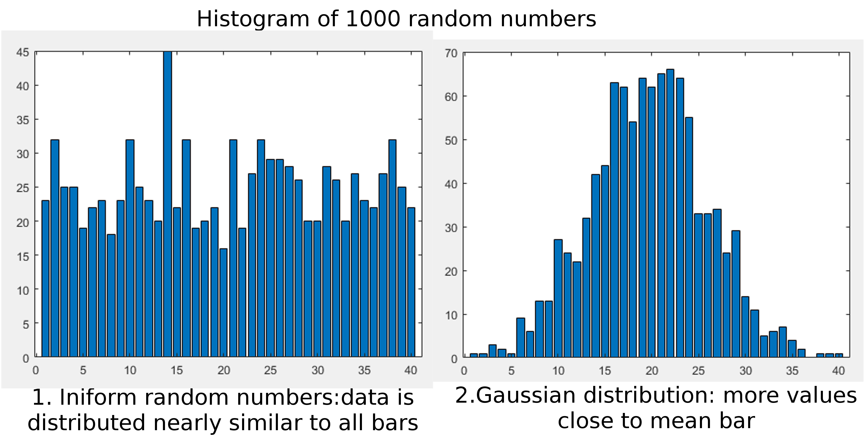
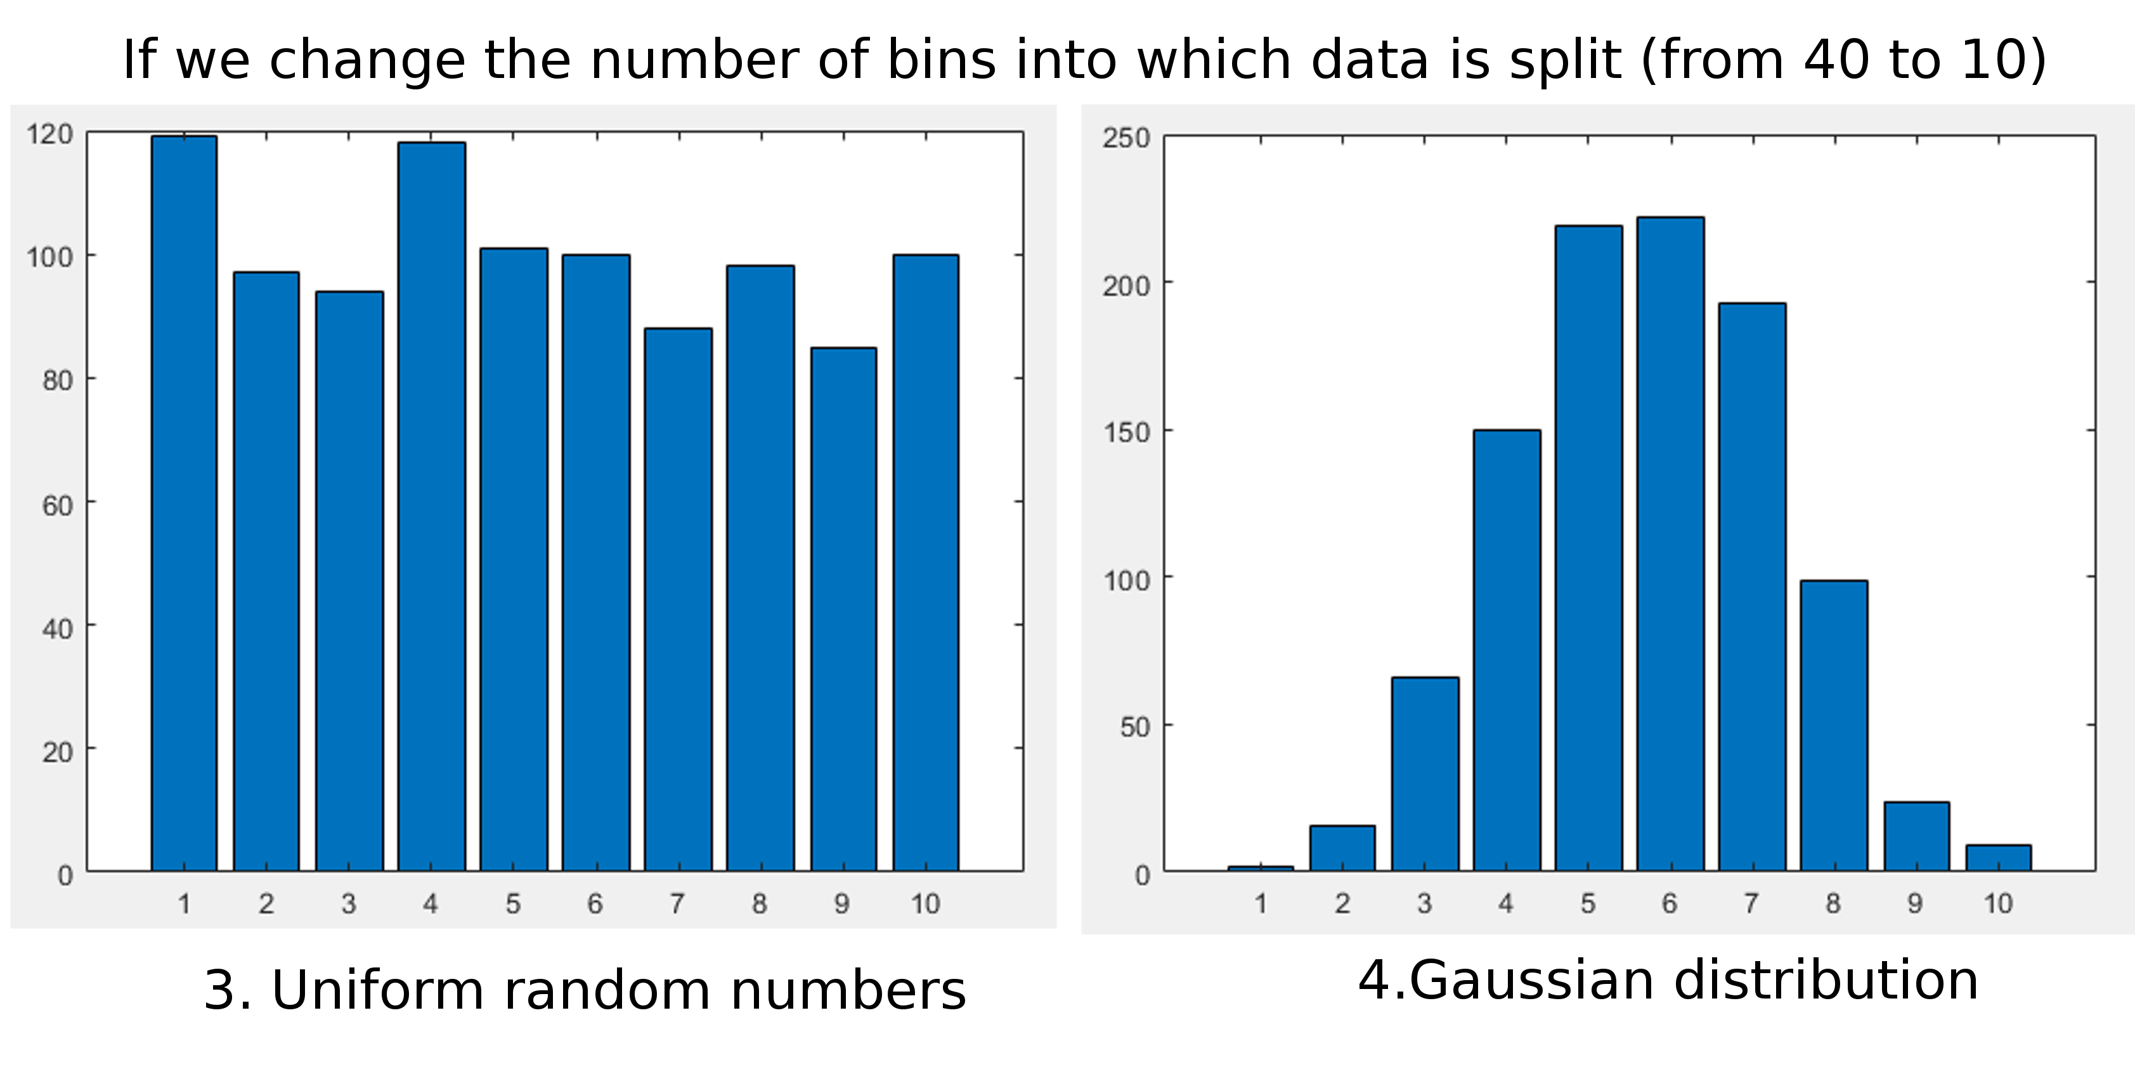
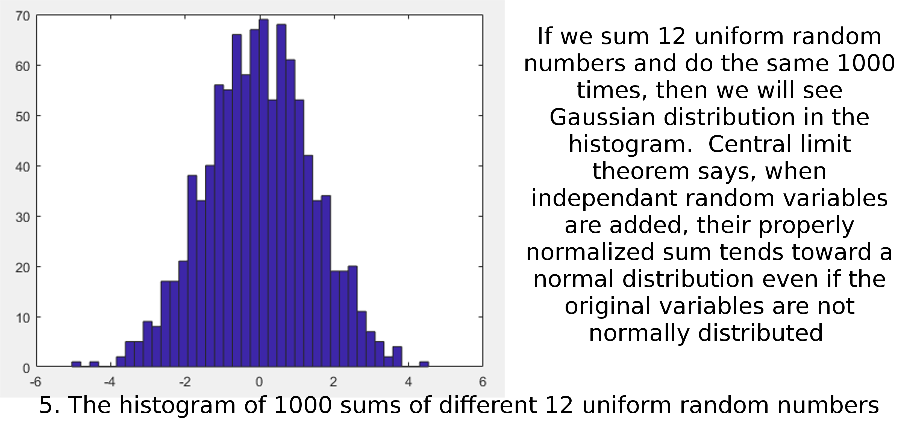

Name Surname: Iustina Ivanova
Email: ii1n17@soton.ac.uk

COMP6229 (2017/2018): Machine Learning Lab 1

